**Are the Older Actually Wiser?**

A Study onCapital Structure Behavior and Age of Internet Firms

**April 2018**

**Jon Gerhartz Ursinus College ‘18**

**Introduction**

When a new technology company is founded, they will almost always rely on sources of startup capital to begin operations. At a basic level, this capital will be made up of either debt, equity or a mixture of the two. The combination of debt and equity a firm takes on is known as capital structure and it is a key indicator of the financial health, stability and potential for growth of a company. Various factors such as market conditions, investor sentiment, tax rate, and the cost of debt, can affect the amount of debt and equity a firm will take on. Literature on this topic also suggests the age of firm impacts their level of debt and equity. As a firm grows from a startup to an established company, their level and ratio of debt to equity will change. In order to understand how different aged firms behave in terms of capital structure, we pose the following question: How does the age of a technology firm impact their capital structure?

**Why Technology is Important?**

According to Forbes, by the end of 2018, the technology industry will be worth $3 trillion, or about 4% of global gross domestic product (Bartels, 2017). This growth will drive economic development through increases in profits and productivity. The recent technology surges of the 1990’s and 2000’s drove significant increases in productivity. As economies become more efficient because of technology, they produced more, which increases profits growth rate. Graph 1 below explains how technology growth since the late 1990’s has driven productivity. As technology grew rapidly during this era, fewer employees were needed to produce the same levels of output. In order to continue the trends of the 1990’s and 2000’s, technology growth of new and current companies will have to continue.

**Graph 1**

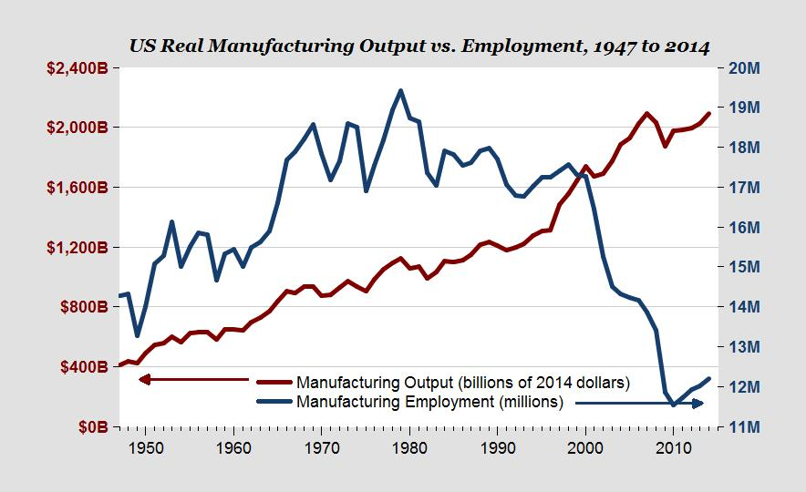

Jennifer Gomes of the Huffington Post argues the market is demanding new technology to increase productivity levels (Gomes, 2017). Additional advancement in automation, machine learning and data analytics will drive future economic growth. Without these advancements, production will stagnate and economic growth will slow down. Therefore, there is enormous pressure on the technology industry to continue to grow and innovate.

**Technology’s Need for Funding**

A crucial part of starting and operating a successful technology firm is obtaining funding. Building and researching the most cutting-edge technological tools requires a large amount of capital. Colman and Robb (2012) studied the financing trends of new technology firms in the United States. Their findings revealed that technology firms raised more capital than all firms and that rapid growth technology based firms raised substantially more capital than all firms and all rapid growth firms.[1] Based on this data, technology firms and rapid growth technology firms require a larger sum of capital than non-technology firms. This demand for capital must be met to allow companies to be successful.

**Literature Review**

There are various methods firms can use to raise money. Some of these methods include: short-term debt, long-term debt, internal equity, and external equity. Capital structure is the makeup of financing vehicles a firm uses to operate and grow their company. Different capital structures can provide unique benefits to a firm. Various sources of literature have studied how capital structure can be used to a firm’s advantage. Theories from this literature include: Capital Structure Theory, Information Gaps and Pecking Order Theory, Manager Preference based Theory and Life-Cycle Theory. Each of these theories provides a separate argument on capital structure behavior.

**Capital Structure Theory**

A key determinate of profit margin among technology firms is capital structure. There are several theories that aim to answer this question. One of the most famous theories is the Modigliani and Miller Theorem or MM Theorem which has been the basis for thinking on Capital Structure since 1958. Modigliani and Miller proposed that in an efficient market without taxes, bankruptcy costs, agency fees, and asymmetric information, the value of a firm has no relation to its capital structure. The basis of this argument is as follows. The required rate of return for an investor buying equity in a levered firm is the same as buying equity in an unlevered firm (Modigliani & Miller, 1958). For example, assume firm B has no debt. When a firm B takes on debt level A, it raises their value by A, because they have more capital at their disposal. However, the risk assumed by that debt raises the required rate of return for an investor buying equity in firm B. This is because there is a risk that firm B might default on their loan and the investor will lose money. The new required rate of return then becomes equal to the rate of return required to invest in firm B at their original value. Investing in firm B at their original value was more risky because they were a smaller firm with less capital. Based on this analysis, the valuation of a firm is not affected by how that firm is financed.

Despite Modigliani and Miller’s initial conclusion about capital structure and firm value, the conditions in which their original model operated do not actually exist. Firms will always be faced with taxes, fees, asymmetric information and will not always operate in a perfectly efficient market. The MM theorem becomes really useful when we add the actual market conditions back into the model. Doing so, we can evaluate how each additional factor impacts firm decisions about capital structure. For example, accounting for taxes in the model produced drastically different results and provides insight on taxation’s effect on capital structure. With taxes, firms can receive a major tax deduction on the value of interest payments on their debt. These cost savings make debt financing significantly cheaper than equity because dividend payments on equity are not tax deductible. They concluded that under these conditions, a firm minimizes the cost of capital by raising 100 percent of their capital via debt. The conclusions of the MM Theorem provide valuable insight into firm decisions on capital structure but do not explain if or how capital structure contributes to profit margin. If all the actual market conditions were put back into the model, what would the Modeigliani and Miller model predict? Further research is needed to find that out.

**Information Gaps and Pecking Order Theory**

Myers and Majluf (1984) theorize there is a disconnect between firm manager knowledge and investor knowledge. When a firm issues common stock, they will want to sell it at a price that reflects their true value. However, if the managers have more information about the value of the company than outsiders, there will be a gap in company value between the opinion of the firm manager and investor. This makes raising capital via equity more expensive because firms are getting a bad deal selling their ownership stake for a bargain. Myer and Majluf also find significant evidence on capital structure preference. Their theory is referred to the Pecking Order Theory which states firm owners prefer types of financing in the following order: personal investment/internal equity, short-term debt, long-term debt, and external equity. Based on the undervaluation of their firm by investors, external equity is the most costly and least preferred method of financing for firm managers.

**Manager Preferences of Capital Structure**

Meeting capital demands is not an easy task for a technology firm. Most technology firms are built on human capital. Human capital provides major potential for profit and an increase in production. However, human capital cannot be used as collateral at a bank. Many technology firms, specifically new ones, have limited access to debt funding because they do not have physical assets that can be used as collateral on a loan. Based on this barrier, it is assumed that technology firms will pursue financing via equity rather than debt. This is a common theory within the discussion of capital structure and technology firms. Hogan and Hutson (2004) support this notion. They studied survey data from 117 managers of new technology based firms or NTBF’s in Ireland[2]. From their survey, they gathered manager preferences on capital structure. Their findings indicate that NTBF’s are more likely to pursue equity-based sources of financing rather than debt based sources. Despite the potential lower cost of debt, the risk of taking on loans outweighs the benefit. Additionally, NTBF managers would rather take on equity which comes with the support and experience of the venture capitalist investor. Hogan and Hutson acknowledge that having the support of an experienced investor is more valuable to the NTBF than the additional cost of equity financing minus debt financing.

**Life Cycle Theory**

The previous studies concluded that firms will have a specific preference of capital structure that will not change over time. Additionally, they have only examined firms at a specific stage such as the startup phase. However, as a firm grows, their availability of different sources of capital changes which affects their preferences on capital structure. Berger and Udell’s Life Cycle Theory of Capital Structure argues firms will use different forms of financing for different stages of growth (Berger & Udel, 1998). In the beginning or small company phase, they acknowledge Myers and Majluf’s (1984) Pecking Order Theory that internal financing is the most preferred form of capital. When these firms do turn to external financing, they found they prefer debt over equity. However, as a firm grows, the gap of information between the insiders and the outsiders begins to close. Becoming a larger public company requires greater transparency so most information about the company becomes public. At this point, the cost of equity decreases because managers get a more accurate valuation of their firm from investors. The firm will now opt to take equity as it is more valuable and does not require the risk of additional debt.

**Theories Explained**

The basis of this study is to determine how the age of a firm affects capital structure overtime. Table 1 below illustrates the relationship between age and capital structure that each theory predicts. Capital Structure is measured by debt to equity ratio. In the empirical analysis section of this paper, we will compare actual results/charts with the charts from table 1.

Explanation of the Pecking Order Theory.[3]

1. The first preference of a firm is to invest personal equity, at this point we assume they have taken on zero debt. This sets their initial debt/equity ratio at 0.
2. As personal funds run dry, firms first preference is to take on short-term debt. Short-term debt is expensive so the amount they will take on will be limited.
3. Eventually, firms acquire large assets such as office buildings. They will have to pay for that building with long-term debt. These large assets are expensive and require a significant amount of debt, which increases the debt/equity ratio.
4. After years as a startup and small company, the firm has now achieved transparency with the equity market and are able to receive equity at cheaper price relative to debt. As a result, they take on equity from outside investors and decrease their debt level/keep their debt level constant. In either case, the debt to equity ratio decreases.
5. In the later years of this company’s life, they are fully transparent and likely a public company. At this point, they have proven to be profitable and can now obtain outside equity at the cheapest rate yet. They continue to grow and take on more outside equity and their debt to equity ratio continues to decrease as debt decreases or stays constant.

Explanation of the Manager Preference Theory

1. This point assumes a company takes an initial loan to get started.[4] This is likely a personal loan because they do not have tangible assets to use as collateral for a business loan. At this point, they may have a small amount of personal equity in the company, but the amount of the initial loan outweighs the amount of person equity so the debt to equity level increases during this period.
2. From early on, managers will take on outside equity over debt therefore, they will keep debt to a minimum and continually take on more equity. This will cause a decline of debt to equity ratio overtime. As they take on more and more debt, the slope of this line will increase further.

Explanation of Life Cycle Theory

1. According to the Life Cycle Theory, when a firm is in the startup phase, they will take on debt rather than equity. This relates to the market transparency explained in the Pecking Order Theory section. In the startup phase, the company cannot obtain outside equity for a good price because investors do not know anything about the company. Additionally, their lack of tangible assets makes them difficult to evaluate. As they grow in this stage and in the small business stage, they will take on more and more debt as needed. This will continually increase debt to equity ratio. Eventually, they will gain transparency in the market and begin taking on outside equity. This will cause a tapering off in the debt to equity ratio until it reaches a maximum point.
2. At the maximum point and below, the debt to equity ratio will decrease as more equity is being added and debt is either paid off or constant. This point in time represents the established company stage where they are likely publicly traded and have full market transparency with investors.

**Table 1: Capital Structure Theories Illustrated**

|  |  |
| --- | --- |
| **Theory** | **Chart** |
| Pecking Order Theory |  |
| Manager Preference Theory |  |
| Life Cycle Theory |  |

**Conclusion**

The above theories all conducted studies on technology firms. However, each of these studies conducted research on private firms and used survey data or financial data collected privately. What is absent from these studies is an analysis of public technology firms. Due to this gap in literature, this study will look at public technology firm data.

The term technology firm which has been used throughout each study has a few common characteristics. In the models presented in this paper, companies in the sample were chosen based on these three characteristics: a technology firm takes on more debt than a regular firm (Coleman & Robb, 2012), a technology firm has less tangible assets than a manufacturing firm (Berger & Udel, 1998) (Myers & Majluf, 1984) and a technology firm is made up largely of human capital (Hogan & Hutson, 2004). Using similar companies, we will be able to compare the results of the model in this study to the results of each of the above theories.

**General Model**

In order to test the above theories we will construct a model using capital structure as the dependent variable and firm age as the independent variable. The general model is below:

*Capital Structure = firm age + market performance + market cost of capital + tax rate + firm income*

Market performance, market cost of capital, tax rate and firm income are included as control variables which could also impact firm capital structure.

**Data**

The sample size in this study is six and is made up of internet companies which fit the key characteristics mentioned above. Data on these companies is annual from 2009 to 2017. We chose this time period based on availability of public data on internet companies and because 2009-2018 is the period of the current bull market. More historical data on these companies is difficult to find as some only recently went public. The six companies chosen were Facebook, Twitter, Ebay, Alphabet (Google’s parent company), Salesforce and Netflix. Each of these meets the key characteristics of a technology firm outlined by the previous literature. Data for market performance and Treasury rate came from the Federal Reserve Economic Data database. The firm data came from Mergent Online list builder which creates a list of indicators of multiple companies over a given timespan.

**Empirical Model**

The below model will be used to measure how the age of a firm affects capital structure.

Model 1:

*Debt to Equity Ratioit = β0 + β1 Firmageit +β2 Firmage2it+ β3 S & P 500t + β4 Effective tax ratet + β5 10yr t-bondt rate + β6 EBITDA Margin + Eit*

The dependent variable in this study is Debt to Equity Ratio. Debt to equity ratio is an effective measure of capital structure because it compares the level of debt a firm has compared to equity. Ultimately, debt to equity ratio measures the risk of capital structure at any point in time.

The Explanatory variable will be firm age. Firm age in this study is the number of years since the company was founded[5]. Based on the Life Cycle Theory of Capital we think age will have a positive relationship with debt to equity ratio in the early years of a firm’s life, then will reach a maximum point and will reverse directions. This represents a quadratic relationship. After a firm exits their startup phase, they will be more transparent and will be eligible for cost effective equity based financing. This will begin to decrease debt to equity ratio as new loans are not taken on, old loans are paid off and total equity value increases.

The S & P 500 index will serve as an indicator of market performance. In this model, we use the mean annual S & P 500 growth rate. Including this variable in the model will account for market conditions which might have an effect on the debt to equity ratio of a firm. In favorable market conditions, companies will grow and will need to take on funding to continue to make new investments. We expect the S & P 500 index to have a negative relationship with debt to equity ratio because when market conditions are increasing, firms can get a better price for equity then when market conditions are decreasing. Therefore, they will likely take on more equity and less debt.

The effective tax rate will be a measure of the tax implications firms are experiencing. As tax rates rise, firms are more likely to use debt rather than equity because they can write off debt to receive a tax refund but cannot do so with equity. Therefore, we expect a positive relationship between effective tax rate and debt to equity ratio. The effective tax rate used in this model is in percent. It was determined by dividing income tax expenses by earnings before taxes or EBIT.

The Treasury bond rate variable will account for the market cost of capital in each year. We will use the 10 year Treasury bond rate in the model. We chose the 10 year rate as it is a general indicator of both long and short term capital costs. If the Treasury bond rate is high, this will raise interest rates on loans making them a less attractive form of financing. As a result, we expect a negative relationship between debt to equity ratio and Treasury bond rate.

EBITDA is the earnings a company gains before interest, taxes, depreciation and amortization are taken out. To calculate EBITDA margin, you divide EBITDA by total sales. This provides a basic measure of profitability based on the cost factors a firm can control. For example, factors that impact EBITDA margin include: costs of goods sold and selling and administrative expenses. EBITDA margin is an effective measure of how efficiently a firm operates and how well they can minimize costs. We chose this measure of profitability because it excluded outside factors such as taxes, and interest which are already represented in the model in the effective tax rate and t bond rate. We expect to observe a negative relationship between EBITDA margin and debt to equity ratio because a highly profitable firm can reinvest their profits into new ventures and do not need as much debt to grow. Additionally, highly profitable firms are more valuable to investors so they can obtain equity at a cheap price relative to their insider valuation of their company.

**Sample Details and Summary Statistics**

Examining the summary statistics of the companies used in the model provides a clear understanding of market conditions from 2007-2017, tax implications of the group as a whole, and the age and performance of the sample. There are a few key characteristics of the sample that are important to recognize before analyzing the empirical results. Table 2 below displays the summary statistics for model 1.

**Table 2: Model 1 Summary Statistics**

|  |  |  |  |
| --- | --- | --- | --- |
| Variable | Mean | Minimum | Maximum |
| Debt to Equity Ratio | .333 | 0 | 1.81 |
| Effective Tax Rate | .135 | -6.08 | 1.74 |
| EBITDA Margin | .197 | -2.29 | .613 |
| Firm Age | 13 | 3 | 22 |
| S & P 500 Growth Rate | .157 | .014 | .324 |
| 10 Year T Bill Rate | .025 | .019 | .037 |

When examining debt to equity ratio of this sample, it is important to note the mean ratio of .333 or about 1/3. On average, firms in this study took on three times as much equity as they did debt from 2009-2017. Compared to the market, the average debt to equity ratio of the S & P 500 during this same time period was 1.11. Given these points, the companies in this sample have much less debt than all companies in the S & P 500.

Some other notable statistics include negative values for an effective tax rate. During these years, the company lost income and therefore go a tax refund that overcompensated for the amount of taxes paid. Additionally, Salesforce had a tax rate of 174% in 2016. They might have incurred this rate because their level of taxable income was less than their level of income tax expense.

**Market Trends in Debt to Equity Ratio Compared to Sample Data**

Equally important to recognize are the market trends in debt to equity ratios from 2009-2017. Graph 2 below outlines the relationship between the S & P 500 mean annual debt to equity ratio from 2009-2017, the sample mean annual debt to equity ratio from 2009-2017, and the 10 year Treasury bond rate from the same time period. A few conclusions can be drawn from this chart. The first is that there is a large difference between the S & P 500 and the sample mean annual debt to equity ratio. The relationship between the two is actually opposite. As the S & P 500 debt to equity ratio rises, the sample debt to equity ratio falls. This inverse relationship indicates the companies in this sample react in the opposite manner in terms of capital structure than all firms in the S & P 500. From this observation, we can infer that different factors are influencing the sample firms’ capital structure decisions than those influencing the S & P 500’s capital structure decisions. An additional take away from the chart is that there appears to be a correlation between 10 year t bond rate and the sample debt to equity ratio but the same relationship does not apply to the S & P 500 debt to equity ratio. It is unclear why the sample companies correlate with the 10 year t bond rate and the S & P 500 companies do not, even though the S & P 500 companies have much more debt relative to equity than the sample companies. A further examination of the sample data is needed to explain such variation.

**Age and Capital Structure**

Considering the cost of capital has a minimal effect on the mean annual debt to equity ratio of the S & P 500 firms, an additional variable must be explaining that variation and the difference in variation between S & P 500 firms and the sample firms. One notable difference between the S & P 500 firms and the sample firms is age. As defined above, firm age in this study is the number of years since the company was founded. The average age of companies in the sample is about 13. According to a Seeking Alpha source, the average lifespan of a firm in the S & P 500 in 2014 was 18. This suggests that at 13 years of operation, these companies only have 5 more years left before a new company replaces them in the S & P 500. Table 3 below shows how the lifespan of S & P 500 companies has significantly decreased over time. Table 3 also shows a projected increase in the company life span which will take place from 2010 to about 2018.

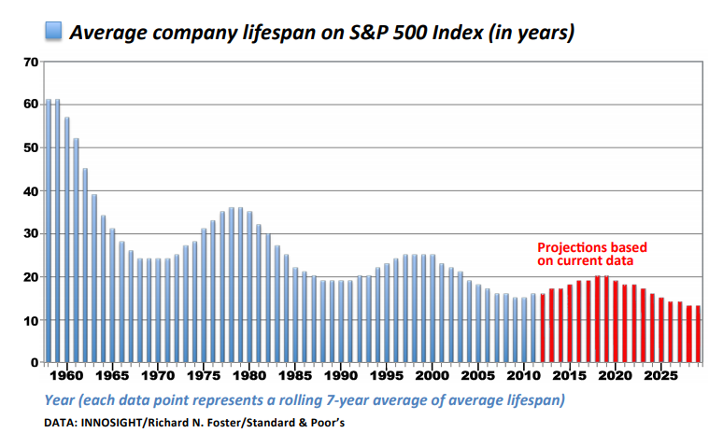**Table 3**

As this lifespan continues to increase during this time period, the average age of companies in the S & P 500 will temporarily grow. This is because older companies are will outlast expectations and fewer new companies will be added in the index. Two conclusions can be drawn from this analysis. First, the companies used in the sample are relatively young compared to companies in the S & P 500. Second, if we consider the Pecking Order and Life Cycle theories, the debt to equity ratio of the S & P 500 should be decreasing from 2010 to 2017 because old companies prefer equity over debt. This is because the average age of the S & P 500 will increase, and fewer new companies will be replacing old ones. Graph 2 illustrates this theory above showing the mean annual debt to equity ratio of the S & P 500 decreasing from 2010 to 2017. In conclusion, the Life Cycle and Pecking Order Theories explain the movement of the mean annual debt to equity ratio of the S & P 500 firms. The question at hand is why do the firms in the sample behave differently from the S & P 500 firms? We will explore this question in the analysis of empirical results.

**Empirical Results and Analysis**

**Debt to Equity Ratio and Firm Age**

The empirical model mentioned above is a panel data set[6]. We ran a regression model using the above variables in addition to dummy variables for year and company. Table 4 below displays the results of the regression analysis. Firm age was statistically significant, showing that age of a firm does have an impact on the capital structure. As revealed in the Summary Statistic Analysis Section, the variation of debt to equity ratio of firms in the sample is not explained by the highlighted theories mentioned earlier in the paper. The parameter estimate for Firm Age (Squared) is .0045. This indicates a positive quadratic relationship rather than a negative quadratic as predicted by the Life Cycle, Pecking Order and Manager Preference Theories. However, it is necessary to take a closer look at this relationship to understand what the exact impact looks like. Also below is graph 3, a plot of D/E and Firm Age [7]. Despite the U-shaped picture in graph 3, the only part of the parabola that represents the data in the sample is the section in the top right quadrant[8].

|  |  |  |
| --- | --- | --- |
| **Table 4: Firm Age Squared vs D/E Ratio**  **Adjusted R2: .61**  **Observations: 54**  **Independent Variables: 6** | | |
| **Variable** | **Parameter Estimate** | **P-Value** |
| Debt to Equity Ratio (Dependent Variable) | - | - |
| Intercept | 140.60*** | <.0001 |
| Firm Age | .6940*** | <.0001 |
| Firm Age2 | .0045*** | .0157 |
| S & P 500 Annual Growth Rate | 308.88*** | <.0001 |
| Effective Tax Rate | .0472 | .2475 |
| 10 Year Treasury Bill Rate | -9156.54*** | <.0001 |
| EBITDA Margin | .1567 | .2208 |
|  | *** = statistically significant |  |

In the case of this model, the explanatory variable age cannot have a negative value. Additionally, debt to equity ratio cannot be negative, the lowest possible value is zero. Therefore, all data points in this sample lie in the positive quadrant. Based on this conclusion, we can explain the Age Squared parameter estimate in the following way. As companies in the sample get older, their debt to equity ratio increases exponentially. Looking back at the average lifespan of a company in the S & P 500 (18 years), we can hypothesize the reason behind this outcome. As these companies are growing older, they are facing increased competition from new companies. In order to compete, the companies in the sample have increased debt level potentially investing in new ventures they hope will once again give them a competitive edge.

**Graph 3: D/E Ratio vs Firm Age**

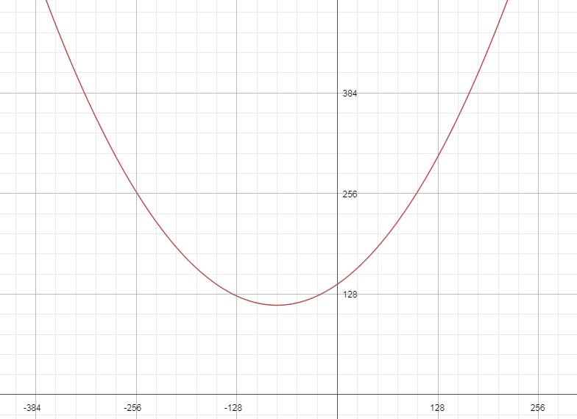

Mathway.com

**Debt to Equity Ratio and Market Performance**

Market performance had a positive significant impact in the model. A 1% increase in the annual S & P 500 growth rate has a .0308 increase on debt to equity ratio. In my hypothesis for the S & P 500 growth rate variable, we predicted a negative relationship with debt to equity ratio. The basis of that argument: outside equity comes at a better value during fair market conditions. However, fair market conditions also increase the competition for equity financing. When stock prices are rising, profits are expected to increase throughout the market. Increasing market wide profitability increases the number of companies investors have to choose from. In this case, the demand for equity financing increases and its price rises. The price at which companies “pay” for equity is called the cost of equity. Typically, the cost of equity rises during periods of stock growth.

**Debt to Equity Ratio and the 10 Year Treasury Rate**

The conclusions drawn from the Summary Statistics Section above are consistent with the empirical results. The relationship between the 10 year Treasury bond rate and debt to equity ratio is negative which also matches the hypothesis. Based on the model, a 1% increase in the 10 year Treasury bond rate will decrease firm debt to equity ratio by 91.57 %. Treasury bond rate has such a large impact because it is directly related to the cost of debt. As Treasury bond rates rise, as do interest rates on loans. If rate rise high enough, the cost of a loan may become more expensive than the cost of equity and equity becomes the more favorable method of financing.

**Model 1 Limitations**

Model 1 successfully predicted 61% of the variation in debt to equity ratio in the sample. However, its results left a few questions on the table. Based on the graph of Firm Age and Debt to Equity ratio, the firms in the sample will exponentially increase their debt to equity ratio moving forward. Considering these firms are extremely successful companies, it is doubtful they would take such a bold and risky course of action. So why did the model predict such results? One problem may be the under presentation of new companies in the data set. As previously mentioned, the mean age of the sample was 13. Only 4 observations in the model contain a value for firm age equal to or below 5 and only 12 contain a value equal to or below 10. These values make up 9.2% and 22.2% of the sample respectively. In order to capture a true arch-shape, as seen in the Life Cycle, and Pecking Order Theories, their needs to be more observations from new firms.

Another limitation of model 1 is we was not able to identify a point at which firm behavior changes using the quadratic model. This is because the minimum point of the quadratic plot didn’t lie in the top right quadrant of the graph.

**Model 2**

In order to make up for the limitations of Model 1, we ran a second model with the sample data. Model 2 is posted below.

Model 2:

*Debt to Equity Ratioit = β0 + β1 Firmageit +β2 Firmage2it+ β3 New + β4 Newage + β5 Newage2 + β6 S & P 500t + β7 Effective Tax Ratet + β8 10yr Treasury Billt Rate + Eit*

The new variables in the variable are New, Newage, and Newage2. Each of these variables was added into the model to make up for the lack of new companies in the sample. The New variable is a dummy variable which has a value of 1 for companies who have an IPO Age of less than 8. IPO Age is a variable that is not included in the model but was used to help capture a better representation of company lifecycle. Using IPO age as a determinate of the New dummy variable, we was able to measure company lifecycle more accurately. This is because companies in the sample have not been public as long as they have been in operation.

The other variables added are Newage and Newage2. Newage is an interaction variable between the New dummy variable and firm age. Adding in this variable along with Newage2 (the new dummy * firmage2) gives extra weight in the model to the new observations. By emphasizing the results of the new observations in the sample, the model should illustrate a more complete picture of the lifecycle of a firm. An additional difference between model 1 and model 2, EBITDA margin was removed due to insignificance[9].

**Model 2 Empirical Analysis[10]**

By weighting new firms who were originally underrepresented in model 1, we was able to achieve significantly different results. Model 2 was able to explain 76% of the variation in debt to equity ratio compared to 62% in model 1. Table 5 below displays the empirical results from the panel regression analysis. The New dummy variable was statistically significant in model and has a negative relationship with debt to equity ratio. This result is different that results found in the Life Cycle and Pecking Order Theory studies which argue new firms will use debt over equity. However, this result does align with the Manager Preference Theory which states new technology firms prefer equity over debt because of their lack of collateral to use against a loan and because of the value they obtain when working with an experienced investor. Despite this result, other variables in the model tell a different story.

The parameter estimate of the Newage2 variable provides a conflicting result compared to the New variable. Graph 4 below shows the negative quadratic relationship between Newage2 and debt to equity ratio. Focusing on the top right quadrant, we see a picture similar to the graphs of the Life Cycle and Pecking Order Theories.

|  |  |  |
| --- | --- | --- |
| **Table 5: New*Age Squared vs D/E Ratio**  **Adjusted R2: .76**  **Observations: 54**  **Independent Variables: 8** | | |
| **Variable** | **Parameter Estimate** | **P-Value** |
| Debt to Equity Ratio (Dependent Variable) | - | - |
| Intercept | 159.03*** | <.0001 |
| New | -6.935*** | .0038 |
| Newage | .9863*** | .0011 |
| Newage2 | -.0334*** | .0006 |
| Firm Age | -.0530 | .8593 |
| Firm Age (Squared) | .0286*** | .0006 |
| S & P 500 Annual Growth Rate | 333.23*** | <.0001 |
| Effective Tax Rate | .0080 | .8075 |
| 10 Year Treasury Bill Rate | -9909.92*** | <.0001 |
|  | Statistically Significant= *** |  |

When the new observations are weighted in the firm age variable, the sample actually does follow theory. Additionally, the new model enables us to identify a maximum age at which firms will change their capital structure behavior. At an age of 15, firms in the sample reach a maximum point and their debt to equity ratio begins to decline. According to the Life Cycle Theory, technology firms begin to take on more equity than debt when they achieve sufficient transparency with the investor market. At this point, investors know enough about the company to identify the risk level of their investment. Once they can achieve this, they can compare that risk level to the risk level of other companies. Investors will then use this comparison to make an informed decision on what company to invest in. They cannot perform this same analysis without knowing enough about a given firm.

The reason why the Newage2 interaction variable conflicts with results of the New variable may be because of the age used for New dummy. We chose 8 years because that split the observations in half with 27 with a value of 1 for new and 27 with a value of 0. This created a well distributed sample that we hypothesized would provide a more accurate representation of the population of internet companies.

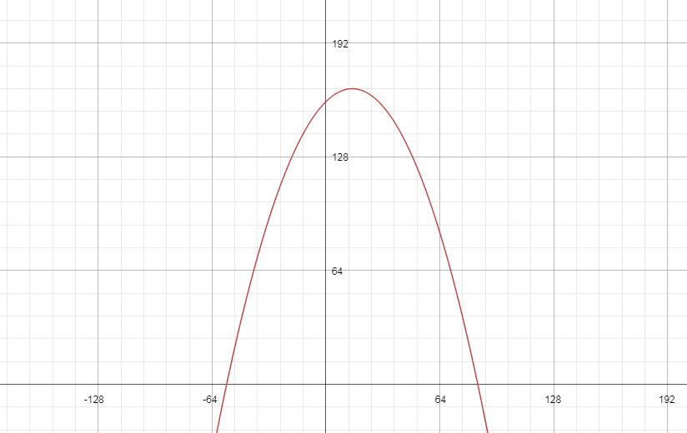**Graph 4: Debt to Equity vs New * Firmage2**

# **New Firm Behavior**

# Based on the results, our model supports the notion that new and old firms behave differently in terms of capital structure. As mentioned about and based on the graph, we see new firms start out with a relatively low debt to equity ratio which rapidly increases over time before eventually tapering off. In their time as a new firm, their level of equity does not exceed their level of debt. This provides evidence that new firms cannot get a good price for equity and therefore will take on a greater amount of debt.

**Old Firm Behavior**

What is interesting is that the age used to determine whether a firm is old or new in this study is 8 but the maximum point of the graph above is at 15. This states that even a firm who is considered to be old will increase their debt to equity ratio for another seven years until they finally start taking on more equity than debt. This makes sense as old firms might have old debt that they have not paid off. However, we can assume that they stop taking on new debt or significantly reduce their amount of new debt that they take on which tapers off their debt to equity ratio.

# **Conclusions and Implications**

# After a thorough analysis of the sample data, several impactful conclusions can be drawn. Model 1 provided valuable insight into the capital structure behavior of the internet firms in the sample compared to all firms in the S & P 500 index[11]. It was interesting to observe the sample firms having a lower mean annual debt to equity ratio from 2009-2017. Also interesting was the correlation between the sample firms and the 10 year Treasury bond rate which did not exist with the S & P 500 firms. Perhaps the firms in the sample have a significant amount of 10 year debt. In the future it would be useful to observe if the debt to equity ratio of internet firms will stay correlated with the 10 year Treasury bond rate. If so, it would be useful to investors to track the 10 year Treasury bond rate as a predictor of internet firm debt to equity ratio. Tracking such data would allow investors to make educated predictions about the future financial health of internet firms.

Using model 1, investors can also make predictions about the financial health of older companies. According to the long term trend of the average lifespan of S & P 500 companies and to model 1, older internet companies may not be able to sustain financial health. As a company get older, their debt to equity ratio may rise out significantly creating a highly levered capital structure. Investors should be leery of older internet companies who take on such leverage in their older age.

Model 2 suggests that firms in the sample behavior similarly to the private technology firms used in the Life Cycle and Manager Preference Theory. One of my initial questions when beginning this research was will new public firms behave the same way new private firms would in terms of capital structure. This study confirms that both private and public firms behave the same. This may suggest that firms who go public have a similar business cycle to private firms who are just starting up. It may be the case that there is a period where new public firms have to prove themselves to the market before receiving fairly priced equity financing. However, if investors realize that a newly public firm has seen a significant decrease in their debt to equity ratio in their tenure as a private firm, they might be able to obtain a large piece of equity at a cheap before other investors catch on. In future research, we would like to collect a larger sample of internet firms, which includes more observations from new firms. In this new sample, we would run model 1 and see how the results compare to the Life Cycle and Pecking Order theories. If they are the same that would indicate the missing new observations in my sample significantly impacted the outcome of the model.

# Bibliography

Bartels, A. (2017, October 18). Global Tech Market Will Grow By 4% In 2018, Reaching $3 Trillion. *Forbes Tech*.

Berger, A. N., & Udel, G. F. (1998). The Economics of Small Business Finance: The Roles of Private Equity and Debt Markets in the Financial Growth Cycle. *Journal of Banking and Finance, 22*.

Chunhua, W., & Meiyan, S. (2013). Relationship between Capital Structure and Performance Evidence based on. *2nd International Conference on Advances in Computer Science and Engineering*, 330-333.

Coleman, S., & Robb, A. (2012). Capital structure theory and New Technology Firms: is there a match? *Management Research Review*, 106-120.

CSI. (2018, 4 21). *Total Market Financial Strength Information*. Retrieved from CSI Markets: https://csimarket.com/Industry/industry_Financial_Strength_Ratios.php?

Foster, R. (2012). Creative Destruction Whips Through Corporate America. *Innosight Executive Briefing*, p. 2.

Gill, A., Biger, N., & Mathur, N. (2011, December). The Effect of Capital Structure on Profitability: Evidence from the United States. *International Journal of Management, 28*(4), 3-15.

Gomes, J. (2017, 2 1). Technology, Not Policy, Will Drive Economic Growth. *Huffington Post*.

Hogan, T., & Hutson, E. (2004). Capital structure in new technology-based firms : evidence from the Irish software sector. *Center for Financial Markets Working Paper Series*.

Mathway. (2018). *Mathway Graph*. Retrieved from Mathway.

Minutemen. (2014, November 6). Increasing Churn Rate In The S&P 500: What's The Lifespan Of Your Stock? *Seeking Alpha*.

Modigliani, F., & Miller, M. H. (1958, June). THE COST OF CAPITAL, CORPORATION FINANCE and the Theory of Investment. *The American Economic Review, 48*(3), 261-297. Retrieved from trading economics.

Myers, S. C., & Majluf, N. S. (1984). Corporate Financing and Investment Decisions When Firms Have InformationThat Investors Do Not Have. *Journal of Financial Economics*, 187-221.

Salawu, R. O., & Awolowo, O. (2009). THE EFFECT OF CAPITAL STRUCTURE ON PROFITABILITY. *The International Journal of Business and Finance Research, 3*(2).

1. Colman, Susan and Bob define rapid growth firms as firms who earned at least $100,000 in revenue within their first year of operation.
2. Hogan and Hutson (2004) define new technology based firms as “independent ventures less than 25 years old that supply a product or service based on the exploitation of an invention or technological innovation”.
3. Each number in this section coincides with the numbers within each chart on table 1 below.
4. The addition of the initial loan is to illustrate how debt to equity ratio will gradually decrease according to this theory because managers prefer to avoid using debt.
5. I used absolute firm age in this model because that is what previous literature did
6. The method used for this panel regression was a standard OLS model with time and cross sectional dummies. There was multicollinearity in the model between time dummies for 2014 and 2015. They were removed from the model as a result. To check for heteroscedasticity, we ran Park’s tests and plotted residuals of each variable. All parks tests were statistically insignificant and the residual plots did not show any significant patterns. Plots of logged residuals were graphed to check for serial correlation patters, no patters were found.
7. Graph 3 was created using the Mathway online graphing tool
8. Top right quadrant highlighted to represent area where sample data lies
9. EBITDA Margin was removed in model 2 because it was insignificant and had a high VIF, indicating multicollinearity.
10. The same tests performed on model 1 were performed on model 2. Model 2 also had multicollinearity so the same time dummies were removed as was EBITDA margin. No other issues were found as a result of the tests. Model 2 is also an OLS model using time and cross sectional dummies.
11. We can make this comparison because the model included S & P 500 data.